**Features of the library-provided streaming videos**

1. Visit the library site at [www.shadygrove.umd.edu/library](http://www.shadygrove.umd.edu/library)
2. Vavigate to to the Library Services section
3. Click on Streaming Video (Films on Demand)

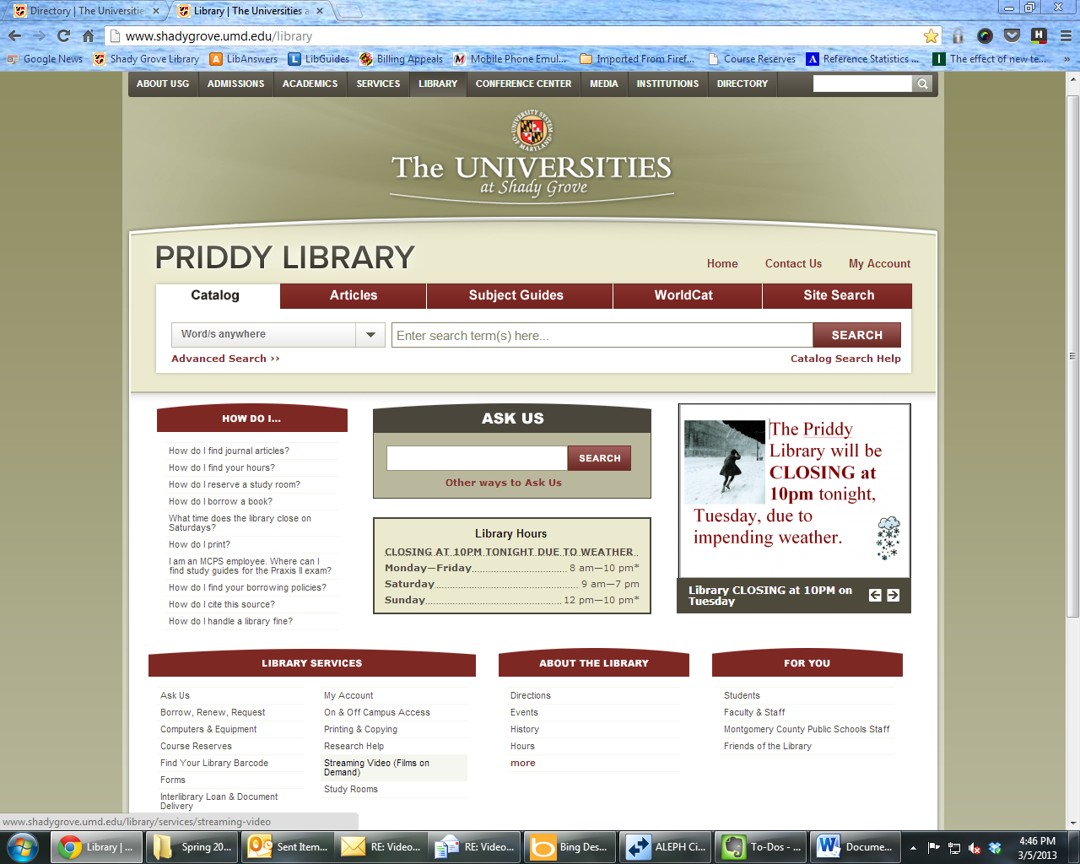

1. Select View Now on the streaming video page to search for and view the streaming videos

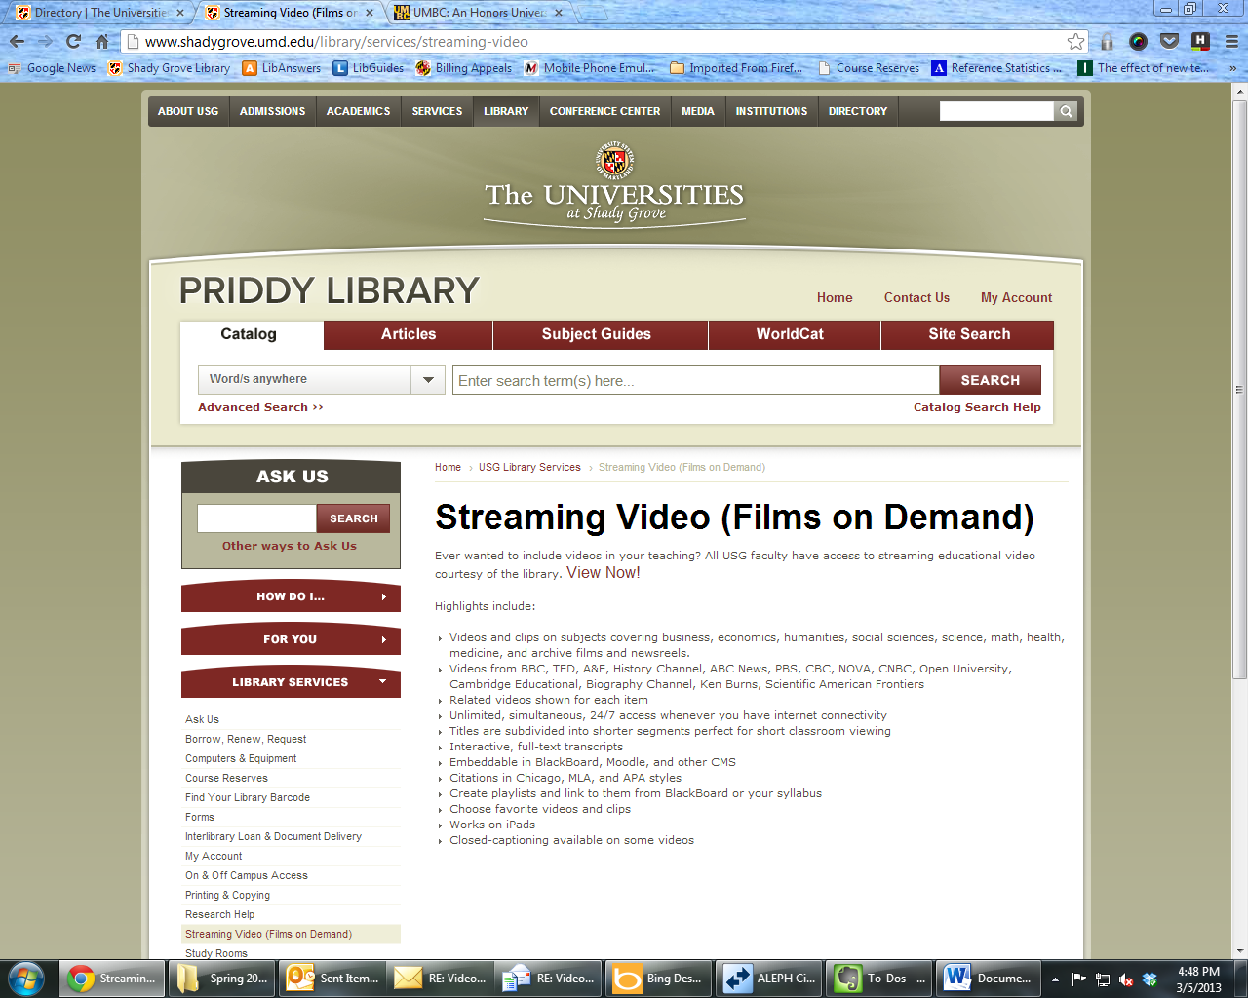

1. Use the **interactive transcript** to jump the specific point in the video that you want
2. **Related Resources** can include Instructor’s Guides and Discussion Topics
3. **Instructor’s Guides** are usually printable PDFs
4. **Link to** **the video** by using the Title URL

**#5**

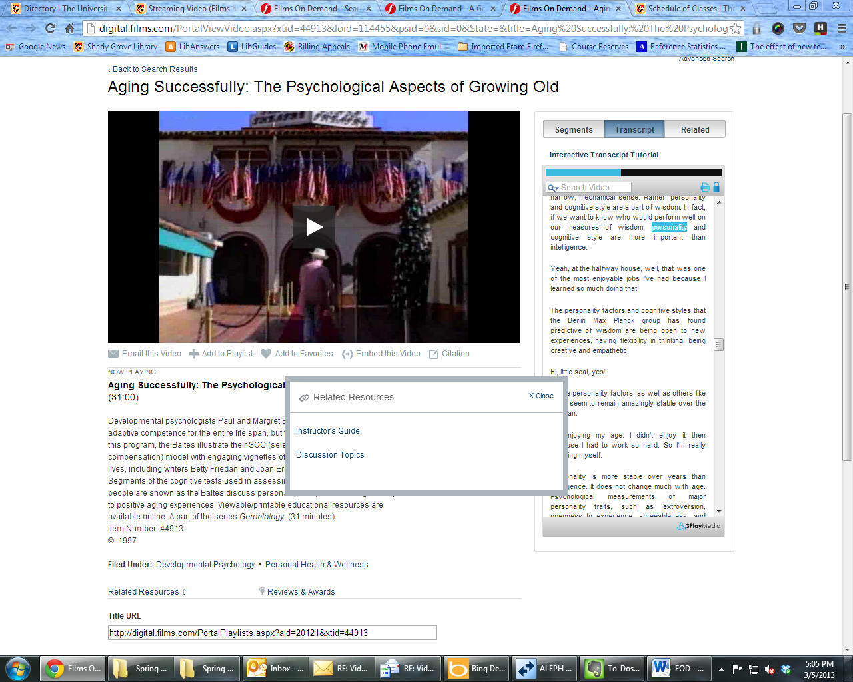

**#7**

**#8**

**#6**